|  |  |
| --- | --- |
| EXERCICES | POINTS |
| Exercise 1 | 10 |
| Exercise 2 | 10 |
| Exercise 3 | 30 |
| Exercise 4 | 50 |
| **TOTAL** | **100** |

**Exercise 1: Boolean expression**

Demonstrate these equalities using the 7 simplification rules you have learnt.

1. (A or B or C) and (!A or B or C) = B or C

=(A or !A) and (B or C)

=True and (B or C)

1. (A and B) or (!A or !B) = True

False or true =True

**Exercise 2: Truth table**

1. **A and (A or B)**

|  |  |  |
| --- | --- | --- |
| **A** | **B** | **A and (A or B)** |
| True | True | True |
| True | False | True |
| False | True | False |
| False | False | False |

A and (A or B) = (A and A) or ( A and B)

= A or ( True and A)

= A

1. **(A and B) or !C or [C and (!A or !B)]**

|  |  |  |  |
| --- | --- | --- | --- |
| **A** | **B** | **C** | **(A and B) or !C or [C and (!A or !B)]** |
| True | True | True | (True and True) or !True or [ True and (! True or !True)] = True |
| True | True | False | (True and true) or !False or [ False and (!True or !True)] = True |
| True | False | True | (True and False) or !True or [True and (!True or !False)] = True |
| True | False | False | (True and False) or !False or [False and (!True or !False)] = True |
| False | True | True | (False and True) or !True or [True and (!False or ! True)] = True |
| False | True | False | (false and True) or !False or [false and (!False or !True)] = True |
| False | False | True | (false and False) or !True or [true and (!Fasle or !false)] = true |
| False | False | False | (Fasle and False) or !false or [False and (!False or !False)] =True |

(A and B) or !C or [C and (!A or !B)]= [A and (B or true)] or [(C and !A) or (C and !B)]

= (A and True) or ( False or false)

= True

**Exercise 3: Ranges**

1. **Simplify** the expressions
2. a < 3 or a > 3

0 1 2 3 4 5 6 7 8 9 10 11 12.....

1. a >5 or a < 6

0 1 2 3 4 5 6 7 8 9 10 11 12 ........

1. a > 2 and a > 12

0 1 2 3 4 5 6 7 8 9 10 11 12​​ 13 14 .....

1. a >= 8 or a > 8

0 1 2 3 4 5 6 7 8 9 10 11 12​​ 13 14 .....

1. a >=0 and a <= 0

-1 0 1 2 3 4 5 6 7 8 9 10 11 12​​ 13 14 .....

1. Draw the shape corresponding to the boolean expression
2. (x = y)

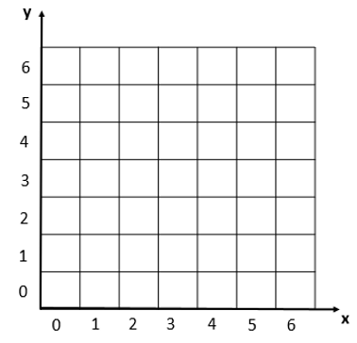

1. (x>2) and not((x>3 and x<4) and (y>2 and y<6))



1. Write the boolean condition for this grid

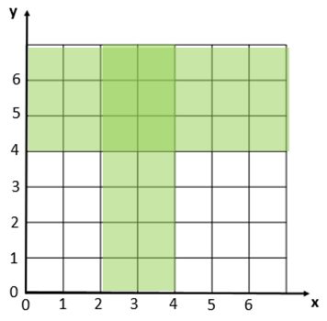

Expression: (X > 2 and X < 4 ) or (Y > 4 or Y > 6)

**Exercise 4: Flowcharts**

1. Draw the tree of conditions

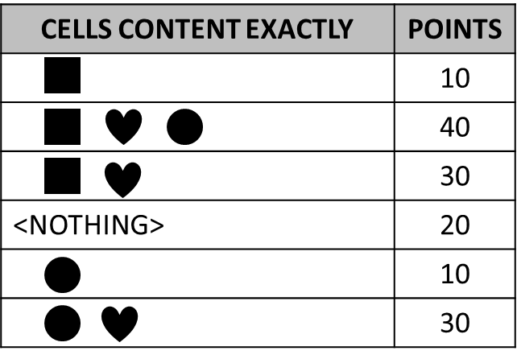

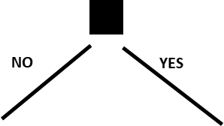

YES



10

30

40

NO

NO

YES

NO

YES

YES

0

30

10

20

YES

NO

NO

1. Say what I do thanks to the flowchart below?
   1. It is Monday, it’s hot and I have homework. What I do? work
   2. It’s Sunday, it’s cold, it’s not raining, I don’t like bicycle and I’m not tired. What I do? Watch movie
   3. It’s Friday, it’s cold and raining, I’m tired but I don’t have homework. What I do?

sleep

* 1. When do I ride my bike? **Give a boolean expression**

Hot and not weekend and don’t have homework and I like bicycle OR

Not hot and weekend and not raining and I like bicycle

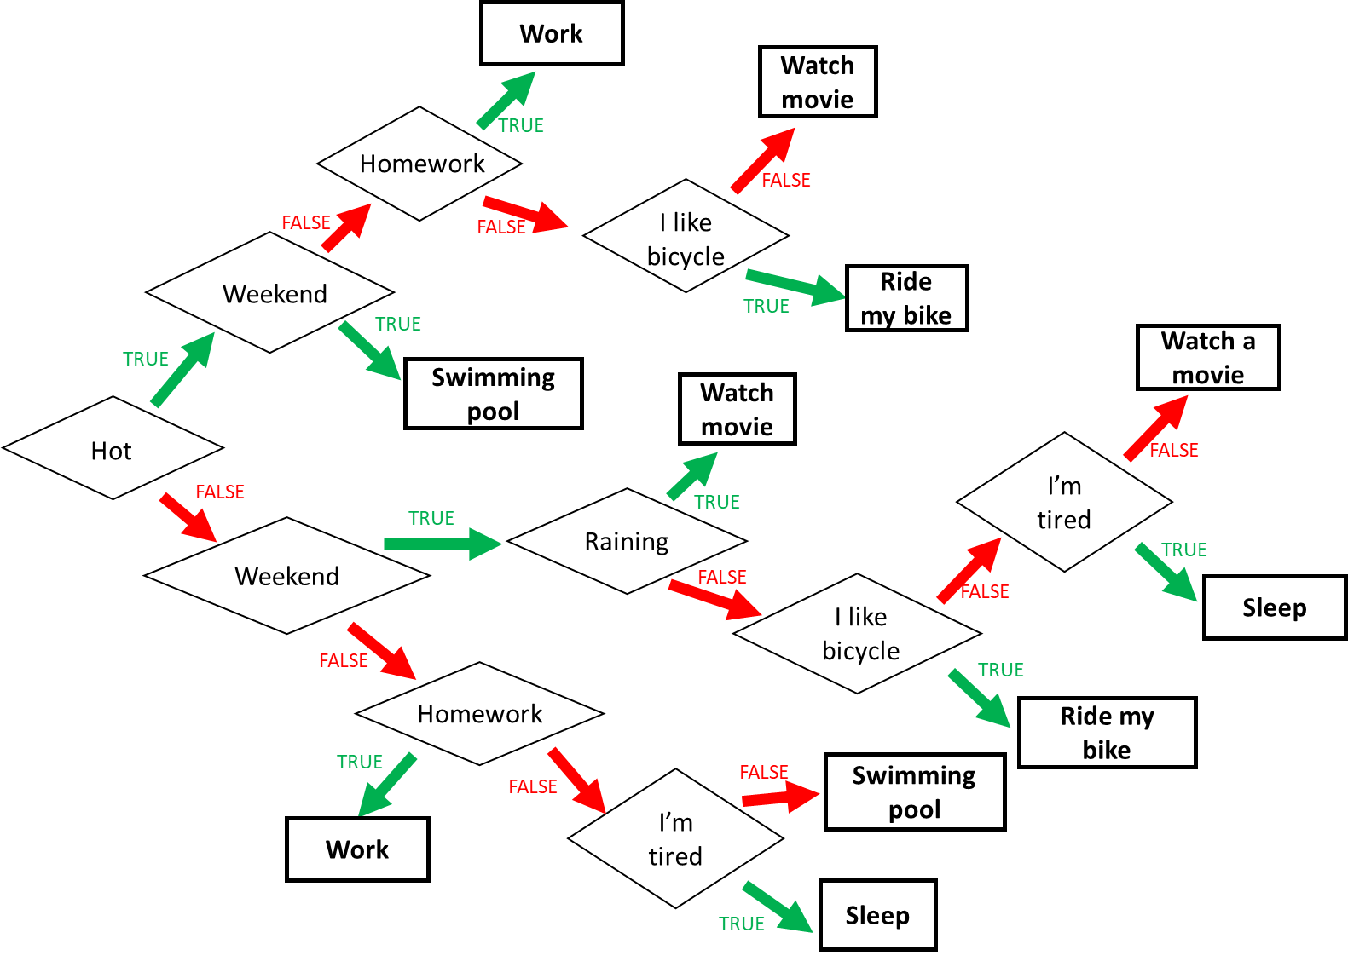

1. Find the boolean expression of **RED** of this flowchart

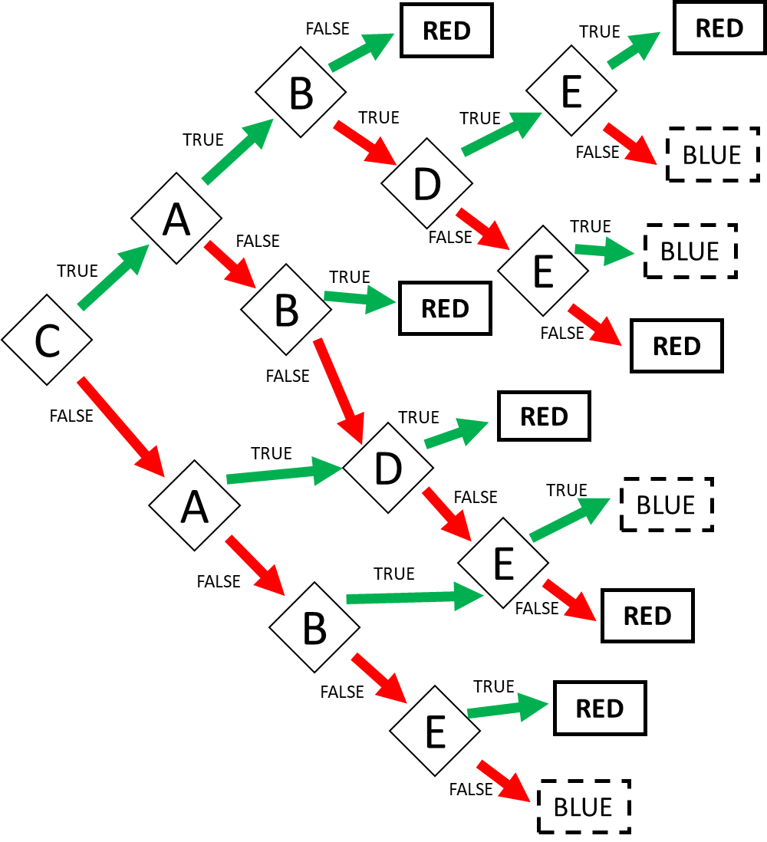

Expression: RED = CAB or CA!BDE or CA!B!D!E or C!AB or C!A!BD or C!A!B!D!E or !CAD or !C!AB!E or !C!A!BE